Steps to configure SAMBA server:
- Mount CD 1
- Install the following three samba packages:
Samba-common
Samba
Samba-client

You can install using the following command:
rpm –ivh /mnt/cdrom/RedHat/RPMS/samba*
- Create a user through which we will work on samba:
#useradd samba1
#passwd samba1
# smbpasswd –a samba1
#passwd: samba
- Check the entry of the user and password in the smbpasswd file using the following command :
#gedit /etc/samba/smbpasswd
- Create a directory :
#mkdir /home/samba1/smbtest
- Create a test file in smbtest directory:
#gedit /home/samba1/smbtest/test

Write hello to this file and save.
- #service smb start
- Configure the smb.conf file using the following command:
#gedit /etc/samba/smb.conf

In this file make the changes as follows:
Workgroup = ms home
Hosts allow = 192.168.1. 192.168.2.127.
Security = share //to make the resources sharable

Make the following changes in share definition part of the same file:
Go to the end and copy the following text:
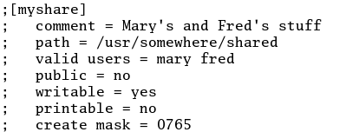

Paste this just below the area from where you copied it and make the changes as follows:
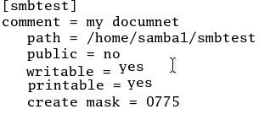
Save the file and close it.
- # service smb start
- #smbclient –L (IP address) –U samba1 //this command is written to check whether the resources are sharable or not.
For Example:
#smbclient –L 192.168.192.129 –U samba1
- Again make some changes to smb.conf with following command:
#gedit /etc/samba/smb.conf

Make printer no:

- Again check the changes using following command:
#smbclient –L (IP address) –U samba1

Steps to configure Samba SWAT(Samba Web Admin Tool)
- Mount CD3.
- Install samba-swat package:
Rpm –ivh /mnt/cdrom/RPMS/samba-swat-2.2.7a-7.9.0.i386.rpm
- #service xinetd start
Or #service xinetd restart
- #service smb restart
- #service xinetd restart
- Configure the following files:
gedit /etc/xinetd.d/swat
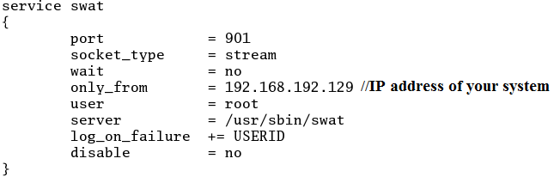
- #service smb restart
- #service xinetd restart
- Open Browser and type:
http://192.168.192.129:901
- A prompt will open where you have to enter user name and password of samba:

User name : samba1
Password : samba

- To share the resources in windows:
Go to command prompt, type IP address and press enter

\\192.168.192.129

